Group 8

**Client-Side App Rubric** <https://github.com/denisecase/pbl-lifeline-links>

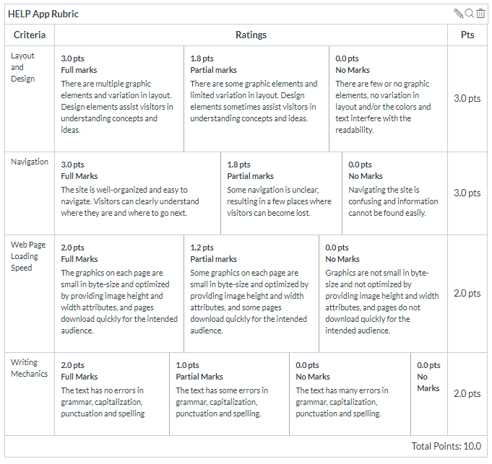

**Team reviewed:**

**Link to the web site:**

<https://jyothsna5268.github.io/group8-help-app/>

**Layout and Design**

Score: 1.8

Comments:

* **Overall**
  + There needs to be padding with the outer border of the site. The text is right on the edge and is difficult to get into.
  + Color is inconsistent thought the site. There is this beautify orange/pink element on the home page but nowhere else. It is also distracting from the overall design.
* **Home**
  + The photo is scrunched and distorted.
  + Use the heading above the photo. It’ll flow better if the image is below because it helps the eye to follow lazily (i.e. people skim text and focus on photos)
  + Center the Local Partners text and shift the actual partner names to the right as if you were pressing the tab button as an indention.
  + Consistency with the headlines is important. Review thought the site
* **Footer**
  + There’s too much information for this type of site.
  + Keep the Copyright information and maybe the name of the site.
* **Program and Values**
  + Looks like there should be pictures across from the text. One solution is have the header text on one side and the body text on the other.
  + Just too much white space
* **Pricing Guidelines**
  + Center the prices at the bottom of the page and don’t use the picture to break the header from the content
  + Center headlines? They should hold importance and that could be a simple alignment variation from the body material.
  + Border space should be bigger
* **Contact**
  + Center headings
  + More border space
* **History**
  + Indent paragraphs, and again larger border space.
  + Maybe use a pull quote in color to add some graphics, giving the readers a break.

**Navigation**

Score: 1.8

Comments:

Have the Home page labeled as such. It took a while to figure out that H.E.L.P. APP was supposed to represent the home page. Have it with the rest of the navigation tabs.

**Loading Speed:**

Score: 2

Comments:

Good, no problems.

**Writing Mechanics:**

Score: 1

Comments:

* There are some missing commas on the History page after dates. It flows better adding that pause.
* Make the set bigger, this is for old people who can’t read itty bitty text.

**General remarks:**

Please know who your target audience is. You are dealing with older people.

* For colors here is a good site to help with ideas (<https://theclare.com/color-therapy-for-seniors/>)
* Fonts
  + Headlines are nice a bold.
  + Body text could be bigger, as people get older they can’t see as well as us youngins’.

**Review performed by:**

Group 2

**Date and time performed:**

November 5- 12:30 PM